**What is Docker Network?**

Docker network is a virtual network that allows containers to communicate with each other and with the outside world. Docker provides a networking feature that enables containers to be connected to one or more networks, each with its own unique IP address.

1. **Default Bridge Network:**

The default bridge network in Docker is a basic network mode created automatically when Docker is installed. It allows containers to communicate with each other and the host using simple network routing.

**Characteristics of the Default Bridge Network:**

* **Limited Inter-Container Communication**:

Containers connected to the default bridge network **cannot communicate with each other by name** (i.e., using container names). They can only communicate by IP address unless you link them explicitly.

* **IP Addressing**:

Each container connected to the default bridge network gets an IP address assigned automatically from the internal Docker subnet range (usually something like 191.18.0.0/24).

* **Isolation from Host**:

By default, containers on the default bridge network are isolated from the host's network, except for explicitly exposed ports. To allow external access to a container, you need to map ports from the host to the container using the -p or -P option.

* **No DNS Resolution**:

Containers on the default bridge network cannot resolve each other by container name. You would need to use user-defined networks (such as custom bridge networks) for name-based resolution.

* **Simple Routing**:

Containers can communicate with each other via IP addresses and ports, but this is basic networking. If more advanced routing is required (e.g., routing to multiple networks), a user-defined network is usually better.

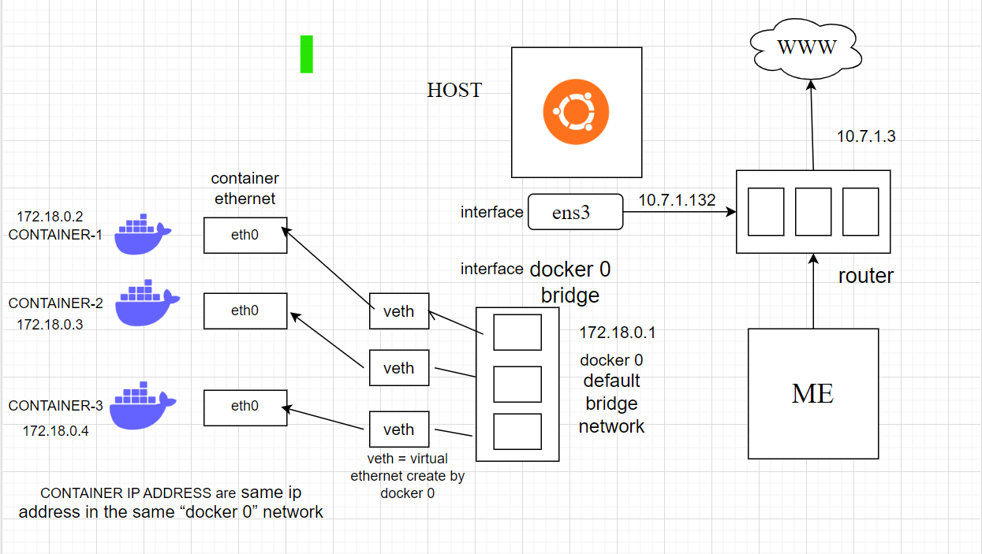

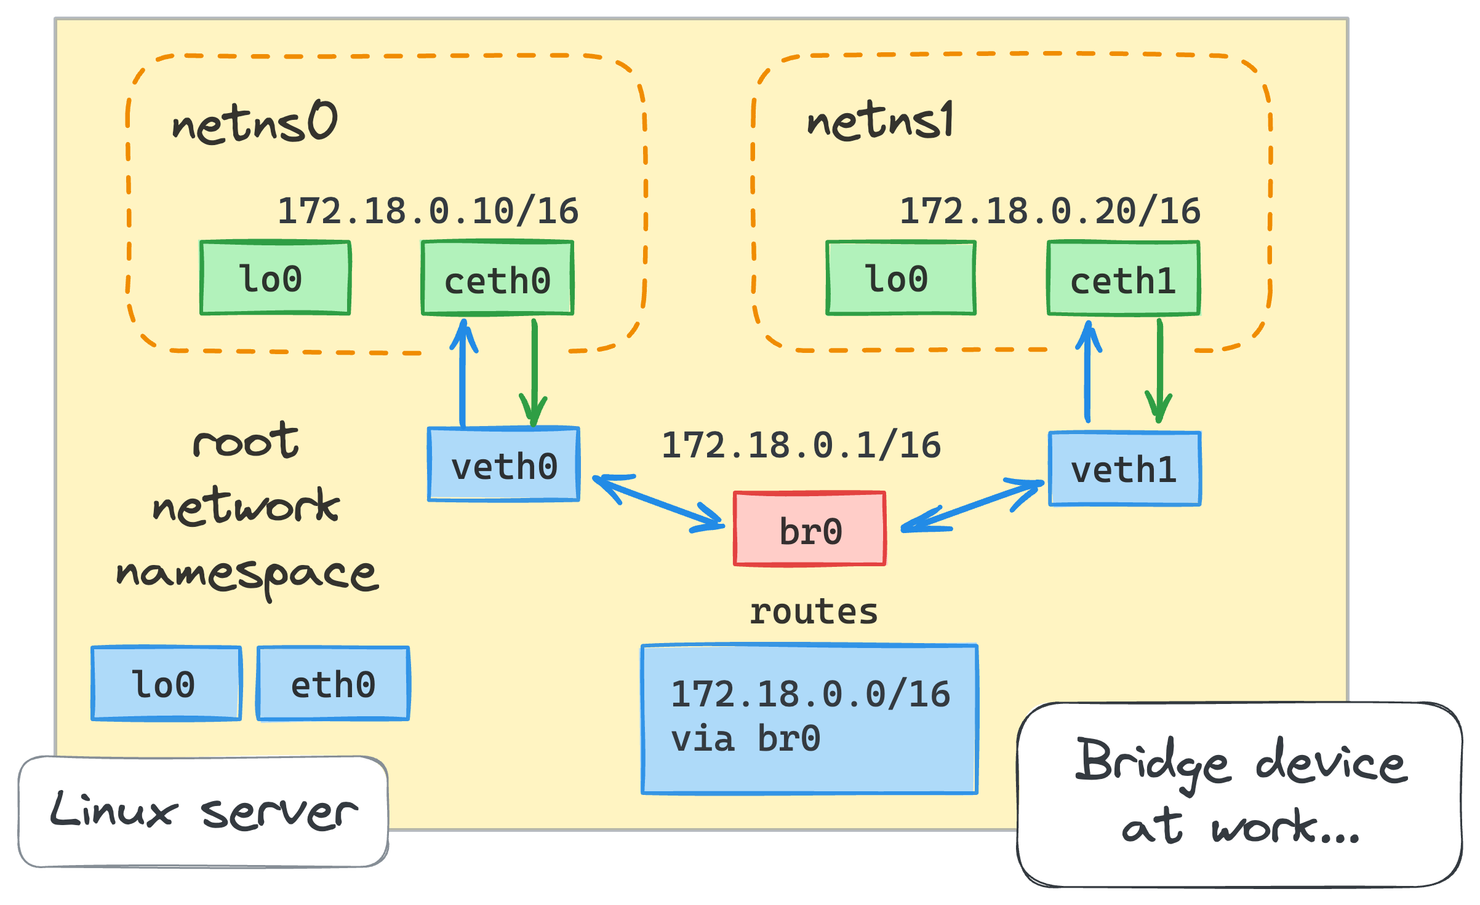

Creating the container using default bridge network and manually exposing the port 80:80

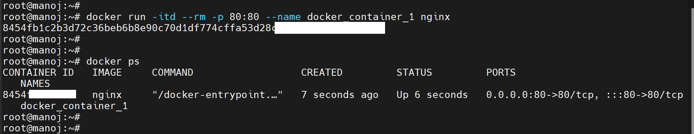

Now we can see that container got default ip address from the docker

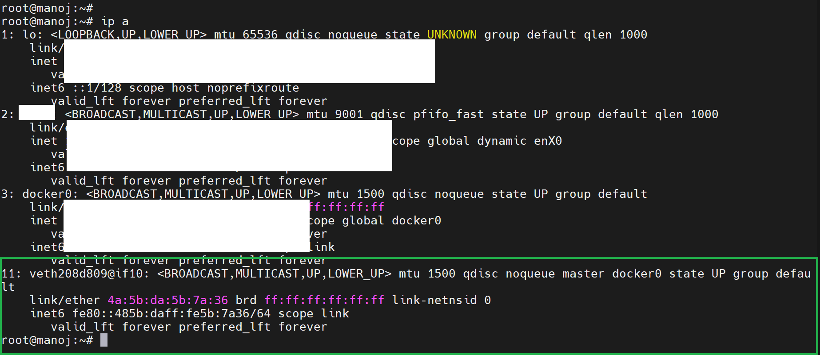

Bridge link show us containers are connected to “DOCKER 0” i.e is default network

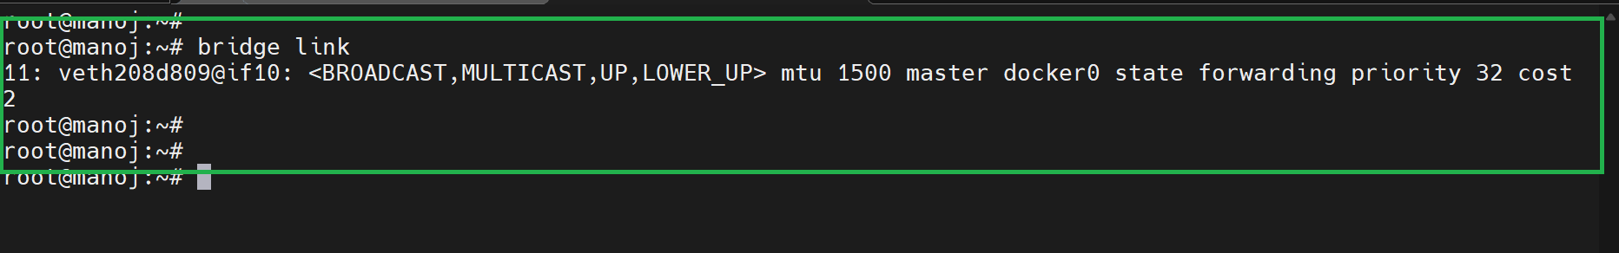

We can see “docker_container_1” with same ip address in the same “docker 0” network

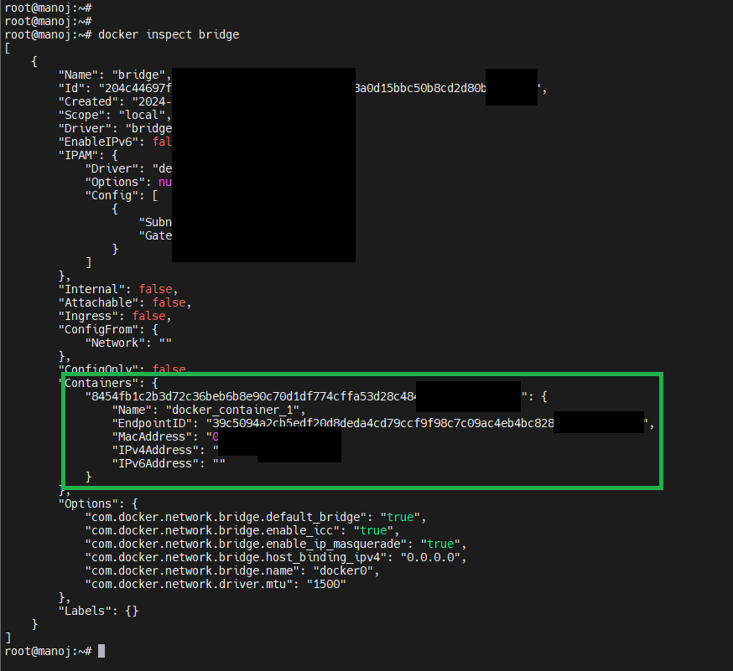

We can see container can ping the internet

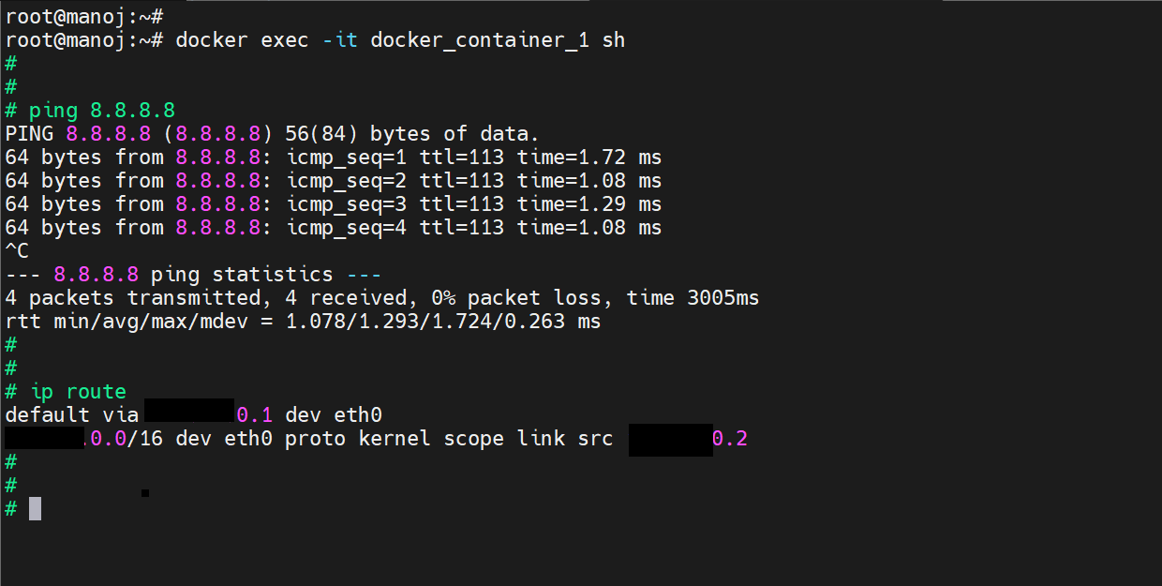

Creating another container name “docker_container_2”

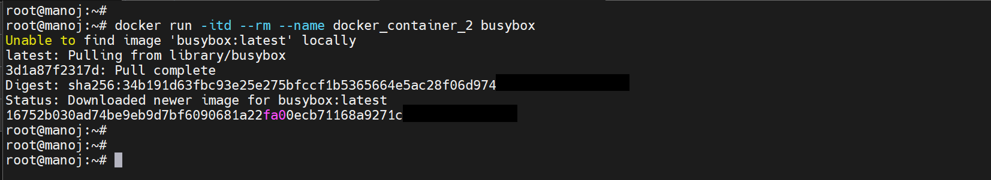

We can see “docker_container_1 and docker_container_2 ” has same ip address in the same “docker 0” network

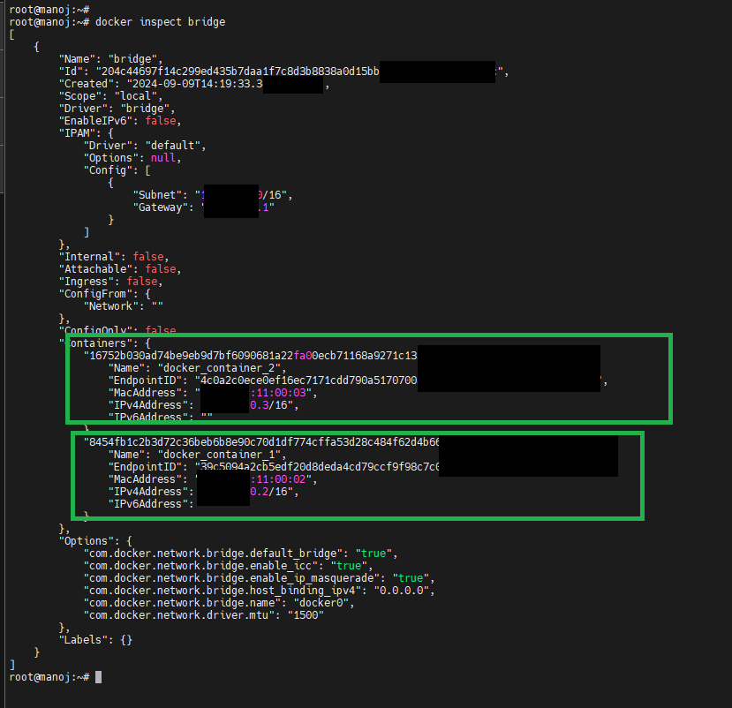

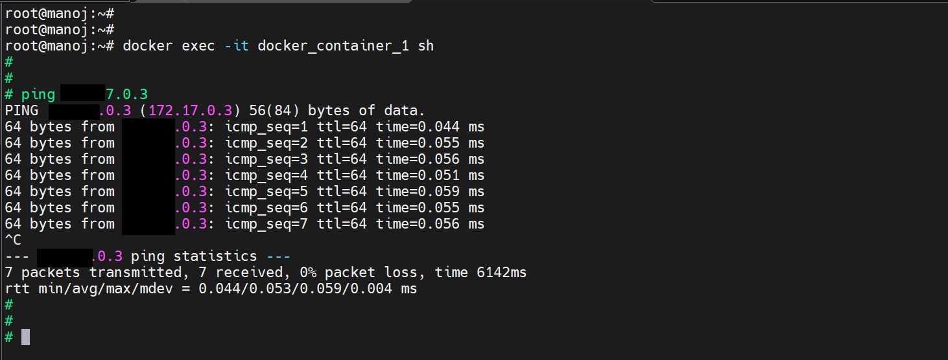

By EXPOSING the port 80 of the container to port 80 of my host, manually we can see the website

